INPUT JSON FORMAT

{

operations: ["frezowanie", "wiercenie", "szlifowanie", "malowanie", "pakowanie"],

rawMaterials :[surowiec1, surowiec2,surowiec3]

products: [{name:produkt1, bom:{surowiec1:23, surowiec2:1}} //tu kolejne 6 produktow],

operationTimes: [

[1, 2, 4, 6, 3, 2],

[1, 2, 4, 6, 3, 2],

[1, 2, 4, 6, 3, 2],

[1, 2, 4, 6, 3, 2],

[1, 2, 4, 6, 3, 2],

[1, 2, 4, 6, 3, 2]

],

orders: [{

name: myOrder1,

dueDate: 2018 - 05 - 05,

items: {

produkt1: 134,

produkt6: 13

}

}],

deliveries[{

name:dostawa1,

date:2018 - 05 - 05,

rawMaterials:[{surowiec1:23,surowiec2:10}]

}]

timeout:300,

maxfGeneration:2000

}

**Dwa moduły:**

**1.parser input/output**

**2. biblioteka z która wystawia API z ktorej parser korzysta, bedzie to metoda:**

class Solution solveSchedulingProblem(class SolverInput data);

oraz zestaw ww. klas które parser bedzie używał

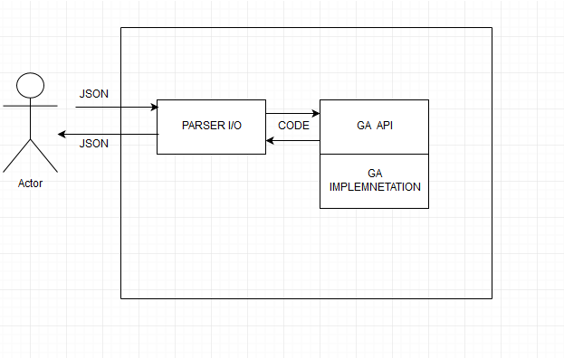

------------------------------------------------------------------------------------------------

class Order,

class Delivery ,

class Products,

class Operation ,

class RawMaterials

class Products,

class SolverInput

class SolverSolution (Harmonogram produkcji)

------------------------------------------------------------------------------------------------

**OUTPUT in JSON FORMAT**

{

schedule:[2018-05-05-12-00:{productName:produkt1,qty:4,

2018-05-05-14-00:{productName:produkt2, qty:4]]

}

albo

{

code: 500,message:”Solution cannot be found”

}

albo

{

code: 500,message:”Invalid input data ”

}